|  |  |
| --- | --- |
| **Date** | 3 August 2025 |
| **Team ID** | LTVIP2025TMID30830 |
| **Project name** | Lease management |
| **Maximum Marks** |  |

**Overview of the Empathy Map:**

Here is a detailed **Empathy Map Document** for your **Lease Management Project**, focusing on understanding the key user personas—primarily **Property Managers**, **Salesforce Admins**, and eventually **Tenants** (future scope). This is essential in human-centered design to build a system that truly meets user needs.

**User Persona: Property Manager**

| **Section** | **Insights** |
| --- | --- |
| **Says** | “I need to track all lease and tenant details in one place.” “Approvals and rent reminders take too much manual effort.” |
| **Thinks** | “Will this system make my work easier or more complicated?” “I hope I don’t miss a lease expiry or payment.” |
| **Does** | Manages lease contracts, enters tenant/property data, approves/rejects lease requests, tracks payments. |
| **Feels** | Wants simplicity and control. Feels frustrated with delays or repetitive tasks. Wants confidence in data accuracy. |

**👤 User Persona: Salesforce Admin / Developer**

| **Section** | **Insights** |
| --- | --- |
| **Says** | “I need to configure custom objects and workflows exactly as the business needs.” |
| **Thinks** | “How can I keep this system scalable and easy to maintain?” |
| **Does** | Creates validation rules, triggers, flows, and scheduled jobs. Manages roles and permissions. |
| **Feels** | Seeks clarity in requirements. Wants to deliver a reliable system. Concerned about technical performance. |

**👤 User Persona: Tenant *(Future Scope)***

| **Section** | **Insights** |
| --- | --- |
| **Says** | “I just want to know how much rent I owe and when it's due.” “Why can’t I check my lease online?” |
| **Thinks** | “Is my lease status approved yet?” “I need a simpler way to communicate with the property manager.” |
| **Does** | Responds to rent reminders (email), waits for approval status, makes payments manually or via offline methods. |
| **Feels** | Lacks control or visibility. Wants transparency and convenience. Feels disconnected without a portal. |

**🔍 Insights from Empathy Mapping**

* 🔹 **Property Managers** value clarity, speed, and automation to reduce workload.
* 🔹 **Admins and Developers** need clean requirements and tools for maintainability.
* 🔹 **Tenants** (as future users) demand simplicity, self-service, and mobile access.

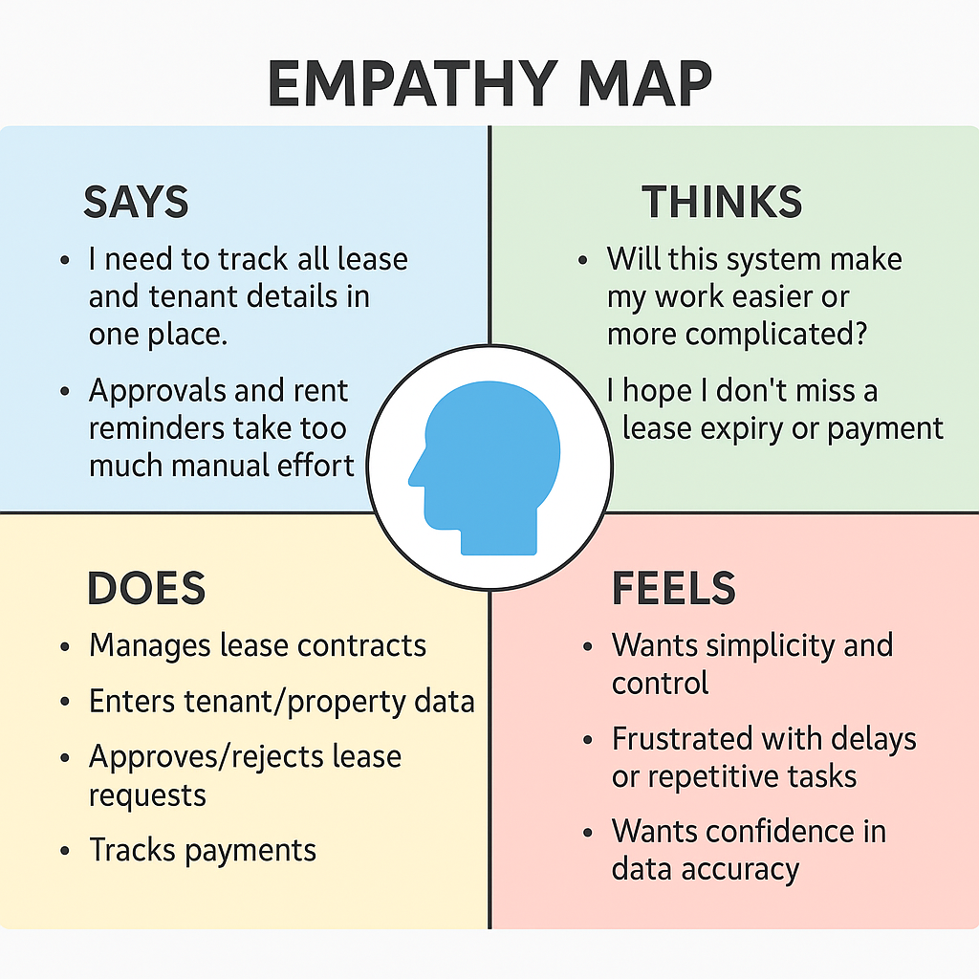

**🧩 How the System Addresses These Needs**

| **Need Identified** | **Feature/Design Implemented** |
| --- | --- |
| Single system for lease & tenant data | Salesforce custom objects (Lease, Tenant, Property) |
| Automated reminders & approvals | Apex scheduled jobs, flows, approval workflows |
| Simple user interface | Lightning App with custom tabs |
| Accuracy and validation | Validation rules and Apex triggers |
| Tenant communication | Email templates for rent reminders, approvals, rejections |
| Self-service (future) | Planned tenant portal via Salesforce Experience Cloud |

**✅ Conclusion :**

The empathy mapping exercise helped shape the Lease Management System to focus not just on technical success but on **real user needs and frustrations**. By understanding what users say, think, feel, and do, the system was designed to be:

* ✅ **Intuitive for property managers**
* ✅ **Maintainable for Salesforce admins**
* ✅ **Future-ready for tenant engagement**

This approach ensures a **human-centered**, role-specific experience that enhances adoption, satisfaction, and system impact.